ROTARYCLUB ANTWERPEN-AMERLOO
HEP 17/08/2023

DISCOVERING BRUGES
Responsible: Babette Van Look (mobile: +32 479 21 75 14) and Fabienne Van Dam (+32 495 50 65 86)
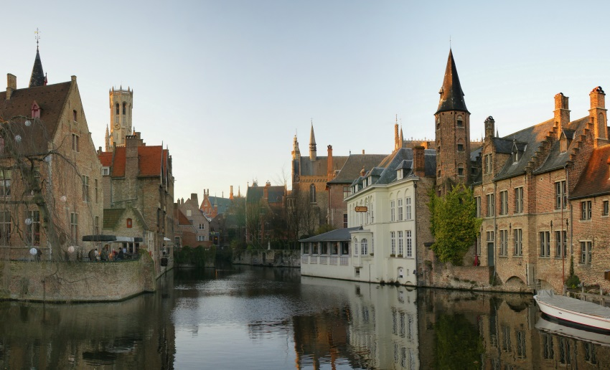
Known as the Venice of the North, Bruges is one of the most beautiful cities in Europe. The current city boundaries still coincide exactly with those of the medieval city centre, and the spaces and structures that were so typical of Bruges in the past have been preserved. This, however, does not mean that there is no room for modern architecture and modern work and living spaces.

PROGRAM 17/08/2023
Time | Activities
09.30h | Pick up at Central Station Antwerp by members of RC Antwerp Amerloo
11.00h | Walking tour Bruges  In small teams you will discover Bruges by the instructions during the city game.
13.00h | Lunch
14.30h | Boat trip  During a roundtrip on the picturesque city canals, you will discover Bruges from quite a different surprising point of view.
15.00h | Free time  Shopping, take a break, time to visit a museum.
17.30h | Departure to Antwerp
19.30h | Dinner in Antwerp with club members
21.30h | Antwerp Hostel
Do not forget: good walking shoes and rain protection

